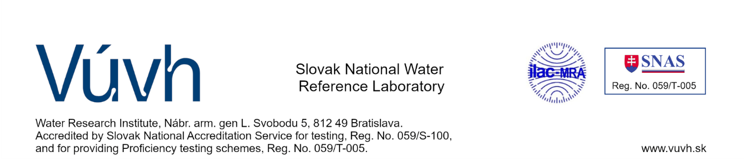
Registration form – for database PT

We hereby register for the database proficiency test (PT)
organised by the Slovak National Water Reference Laboratory (SNWRL) in water analysis
Organisation
Address
VAT number
Contact person |  | Tel
 |  | E-mail
Laboratory |  | Accredited in this field |  | yes / no
Address
(if different from address above)
Contact person for PT |  | Tel
 |  | E-mail

We are interested in participating in Proficiency testing schemes and sending for us applications to selected fields PT:

- chemical methods

Basic chemical analysis
Trase inorganic analysis
Trace organic analysis
Radiochemical analysis
- biological methods

Hydrobiological analysis

Date: Stamp and Signature:

Record SNWRL | Received on: | Taken over by a person: | Registartion number:

